

Department of Electrical and Information Engineering
University of Ruhuna
Mini Project Report
Web Application Development EC4307

EventEase Smart Event Management and Registration Platform

Name | Prasadi H. D
Reg.No | EG/2023/5792
GitHub repository | https://github.com/prasadilmi2003-lgtm/eventfull

- INTRODUCTION
Finding events, registering for them and managing attendance are still done with scattered tools such as social media posts, forms and spreadsheets. EventEase is a full-stack web application developed using the MERN stack (MongoDB, Express.js, React.js and Node.js) that brings these tasks into one integrated platform. Organizers can publish events and define ticket types, attendees can search for events, book tickets and receive unique QR-code tickets, while administrators can review events and manage user accounts. The application uses MongoDB for persistent data storage, providing a centralized and efficient solution for event discovery, ticket booking and attendance management.

1.1 Objectives
- Provide complete Create, Read, Update and Delete (CRUD) operations on the main entity, events, backed by MongoDB.
- Let attendees search, filter and sort events, and book tickets without the system ever selling more tickets than exist.
- Issue a unique QR ticket for every seat and let organizers verify and check in attendees at the entrance.
- Support three roles (attendee, organizer, administrator) with permissions enforced on the server.
- Validate input on both the client and the server and show clear error messages.
- Provide a responsive, consistent interface that works on desktop, tablet and phone.

1.2 Users and roles
Role | What the role can do
Attendee | Register and log in, browse and search events, save favorites, book tickets, view QR tickets, cancel bookings, write reviews, edit profile.
Organizer | Create, edit, submit, cancel and delete own events with ticket types; see attendee lists and sales analytics; check attendees using their QR code.
Administrator | View platform statistics and reports, approve, reject or unpublish events, suspend or reactivate user accounts.

2. Technologies and System Architecture
2.1 Technologies used
Layer | Technology | Purpose
Frontend | React 19, Vite, React Router 7 | Single-page application with client-side routing and fast development builds.
Styling | Tailwind CSS 4, Lucide icons | Responsive layout and a consistent violet design system.
HTTP client | Axios | One shared instance that sends the login cookie with every request.
Backend | Node.js, Express 5 | REST API with routes, controllers and middleware.
Database | MongoDB, Mongoose 9 | Document database with schemas, validation, indexes and references.
Security | JWT, bcryptjs, Helmet, CORS, Zod | Authentication, password hashing, secure headers and request validation.
Extras | qrcode.react, Google Gemini API | QR ticket images and an AI help chatbot
Tools | Git and GitHub, MongoDB Compass, VS Code | Version control, database inspection and development.

2.2 Architecture
This is use a three-tier architecture. The frontend, developed with React, communicates with the backend through Express REST APIs, and the backend connects to the MongoDB database to store and retrieve data. During development, Vite forwards all /api requests to the backend running on port 5000. This also allows login cookies to work properly without additional cross-origin settings.

This project is split into 2 folders, those are clients and server.
Area | Main endpoints
Authentication | POST /api/auth/register, /login, /logout; GET and PATCH /api/auth/me; forgot password and reset password.
Events | GET /api/events (search, filter, sort, pages) and /featured; GET /api/events/:id; POST, PATCH and DELETE /api/events; POST /publish and /cancel.
Organizer | GET /api/organizer/events, /dashboard, /events/:id/attendees and /analytics.
Bookings and Tickets | POST /api/bookings; GET /bookings/my and /:id; POST /bookings/:id/cancel; GET /tickets/my; POST /tickets/check-in.
Admin | GET /api/admin/dashboard, /users, /events, /reports; PATCH /users/:id/status and /events/:id/review.

3. Implementation
3.1 CRUD operations on events
Operations | User action | API | Rules Enforced
Create | Organizer fills in the Create event form with ticket types and saves a draft. | POST /api/events | Server validation; new events start as draft and the organizer is taken from the login, not from the form.
Read | Visitors browse, search, filter by category, date, price and location, sort and page through events; open an event page. | GET /api/events, /api | Only published events are public; drafts are visible to the owner and administrators.
Update | Organizer edits the event in the same form. | PATCH /api/events | Only ownwer or admin can cancelled the event
Delete | Organizer clicks the bin icon and confirms in a dialog | DELETE /api/events | Remove related tickets and favourites
3.2 User Interface
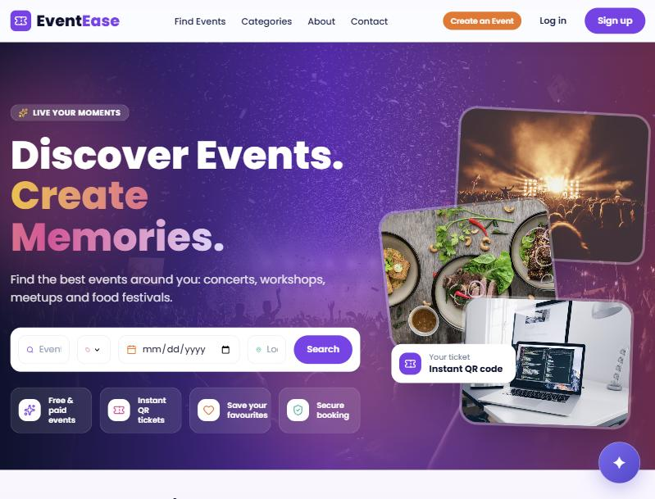  Figure 1: Home page with search bar | 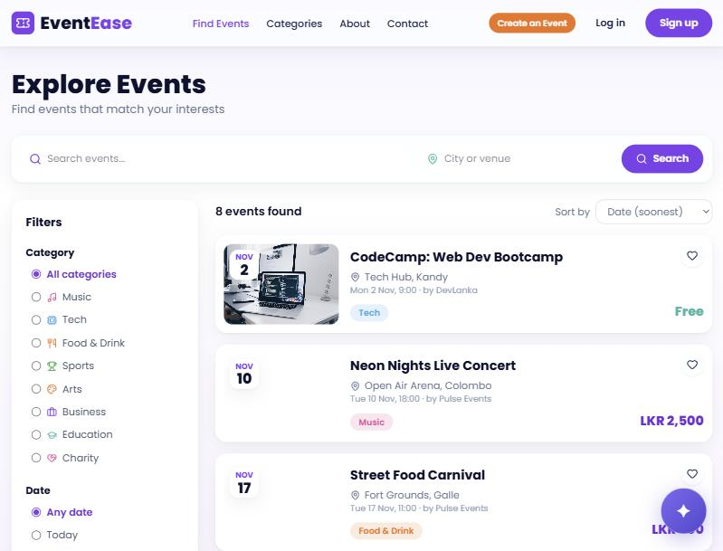  Figure 2: Explore events page with filters and sorting
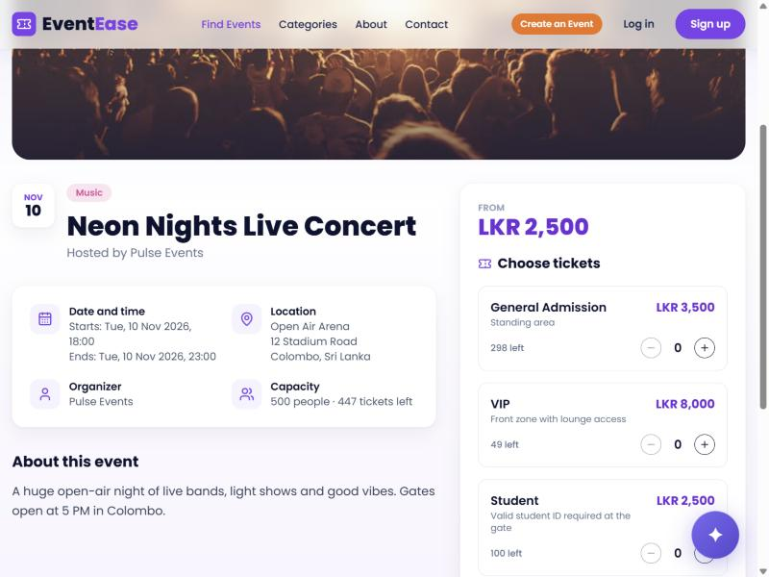  Figure 3: Event details and ticket selection | 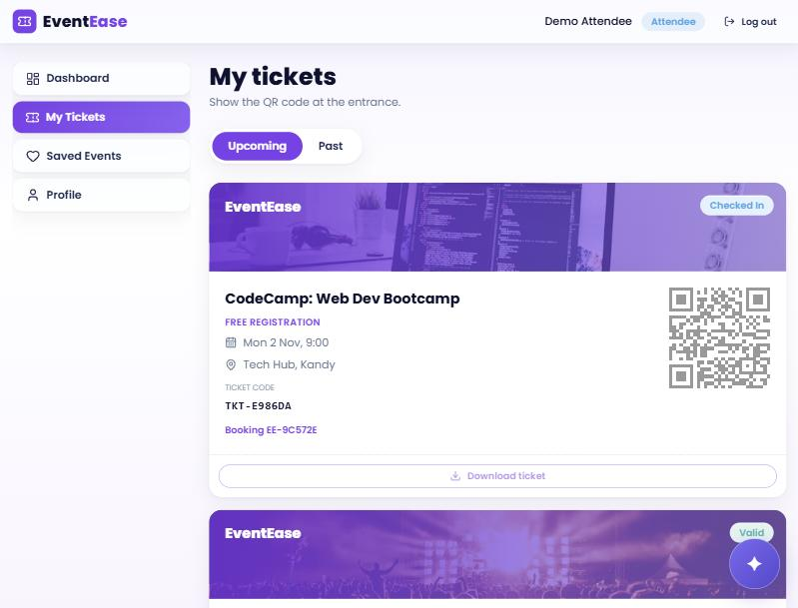  Figure 4: Attendee tickets with QR codes
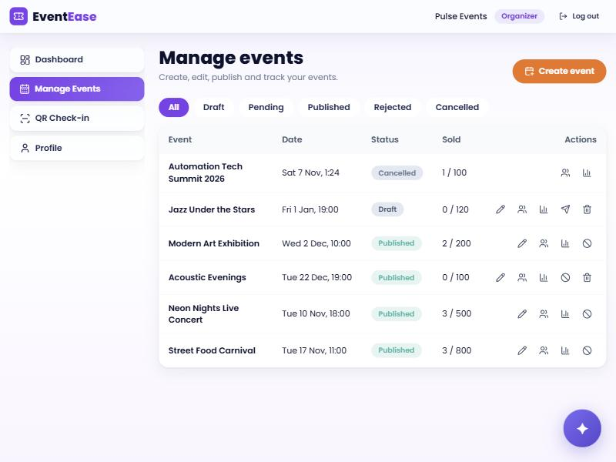  Figure 5: Organizer event list with edit, delete and other actions | 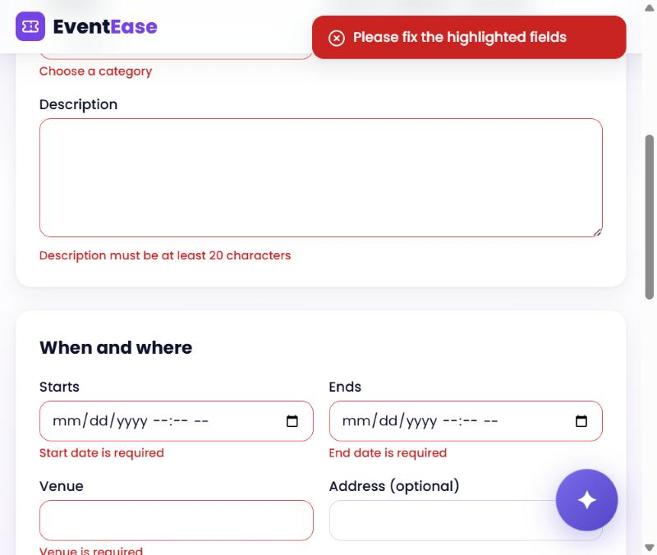  Figure 6: Create event form showing validation errors
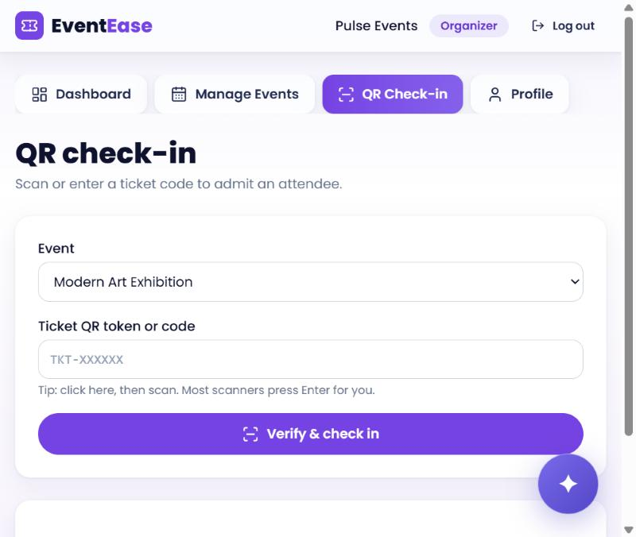  Figure 7: QR check-in page for organizers | 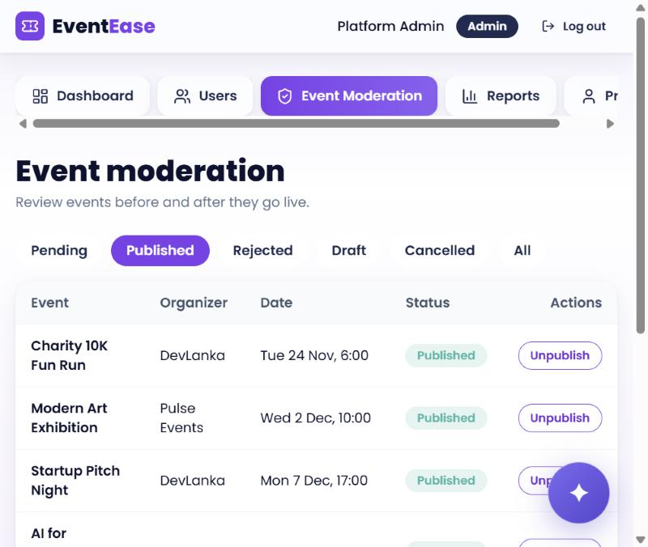  Figure 8: Administrator event moderation
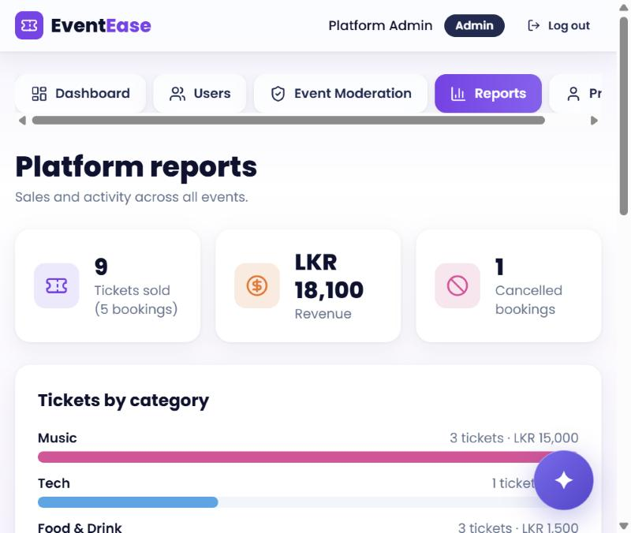
Figure 9: Administrator platform reports

4. Database Design
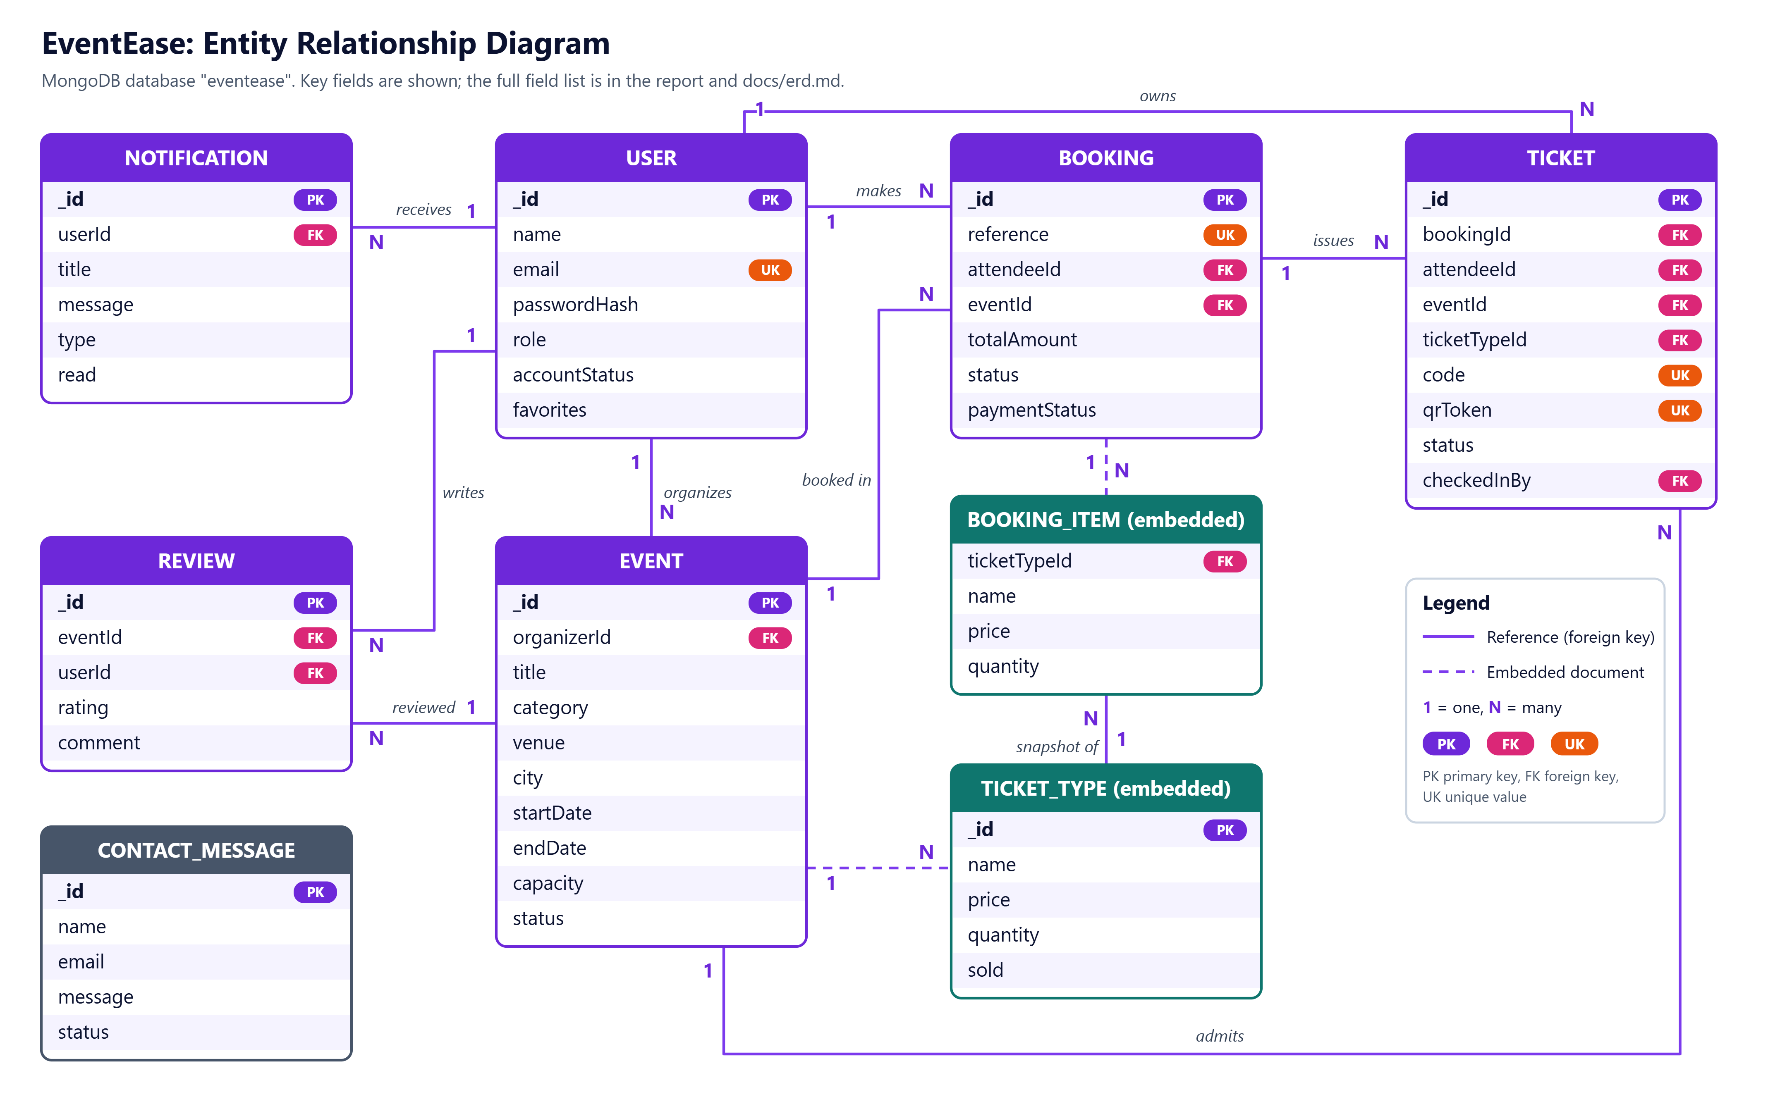
Figure 10: Entity relationship diagram of the EventEase database (PK = primary key, FK = foreign key, UK = unique)

